**When faced below error follow the given steps- total (5 steps)**

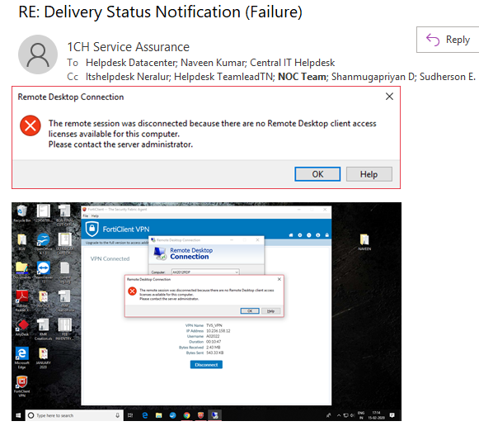

**Solution**

1. Run as mstsc / admin

Log into AXTS01 (10.238.180.20) – as GCP admin user.

Search Remote Desktop Licensing Manager

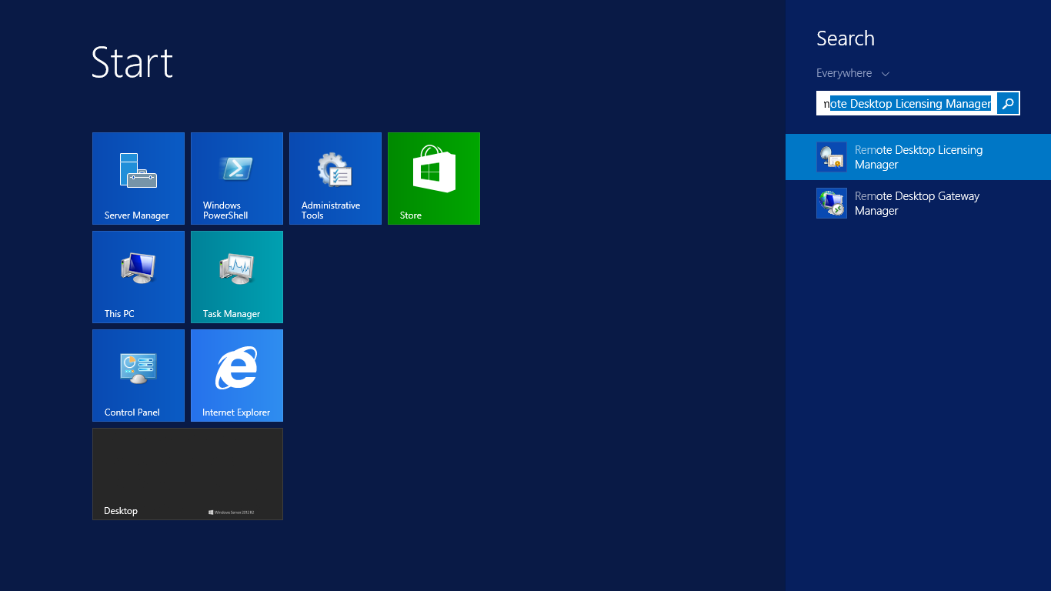

1. Select the server on left side and select Windows server 2012- Installed RDS per device CAL which has total 300 License

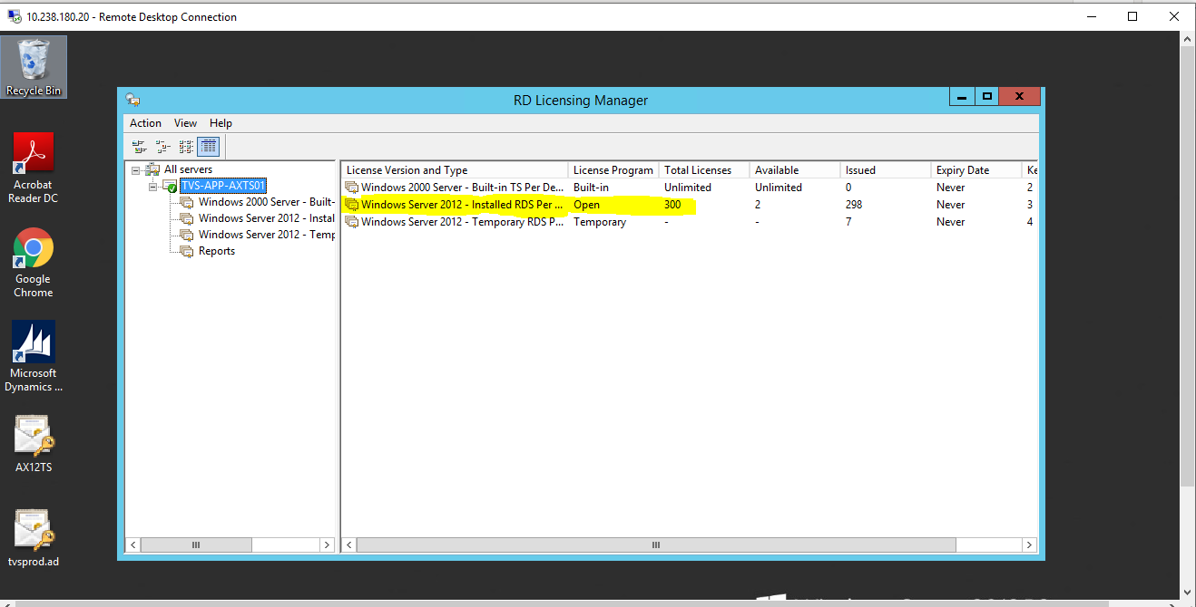

1. Sort the items for January by selecting Issued ON at top

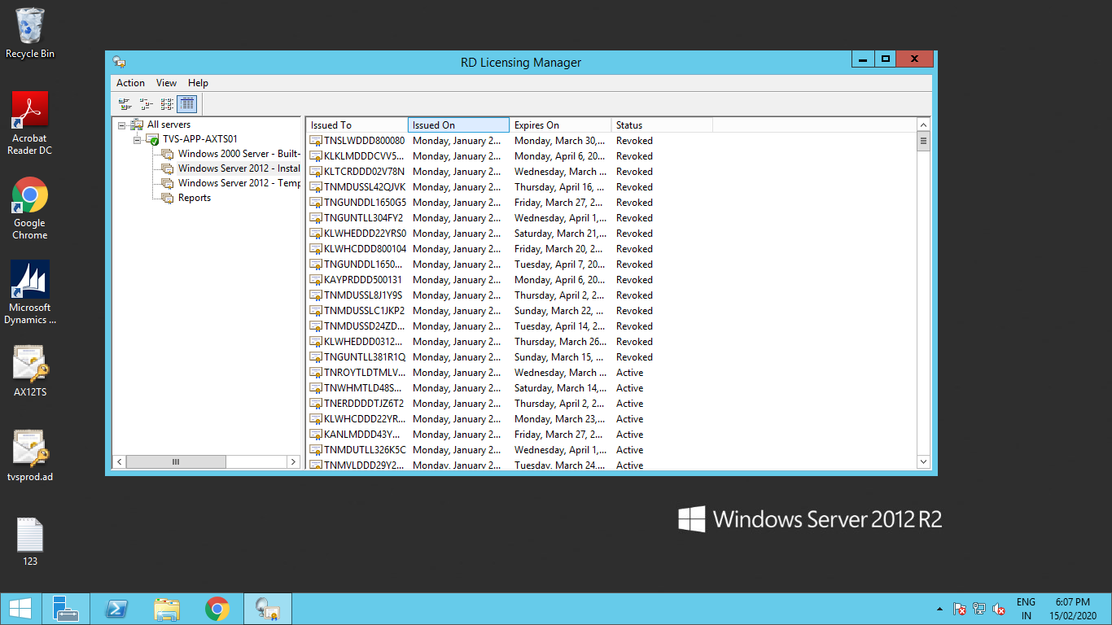

1. Select the latest active-> Right Click-> Revoke License.

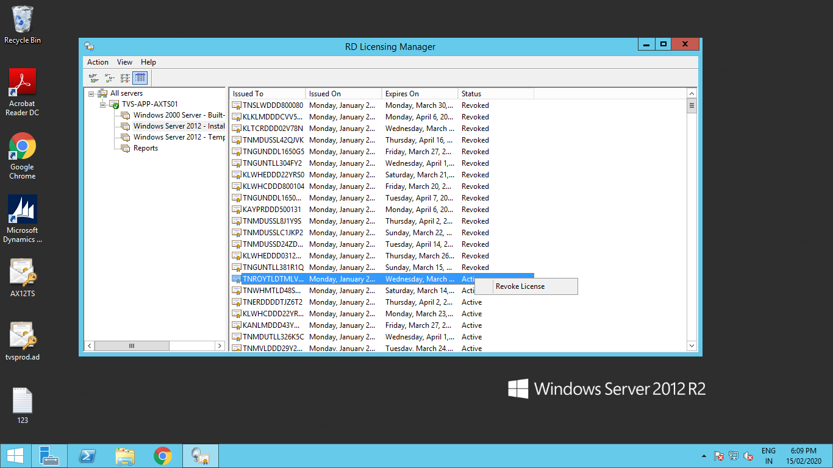

1. Do the revoking for atleast 8-10 times to resolve issue.

